UNIT 1: What is the CNC Machine?

I. READING COMPREHENSION

Now that we have seen what the NC machine is and its various parts, it is easier to understand what the CNC machine is. CNC is the short form for Computer Numerical control. We have seen that the NC machine works as per the program of instructions fed into the controller unit of the machine. The CNC machine comprises of the mini computer or the microcomputer that acts as the controller unit of the machine. While in the NC machine the program is fed into the punch cards, in CNC machines the program of instructions is fed directly into the computer via a small board similar to the traditional keyboard.
In CNC machine the program is stored in the memory of the computer. The programmer can easily write the codes, and edit the programs as per the requirements. These programs can be used for different parts, and they don’t have to be repeated again and again.
Compared to the NC machine, the CNC machine offers greater additional flexibility and computational capability. New systems can be incorporated into the CNC controller simply by reprogramming the unit. Because of its capacity and the flexibility the CNC machines are called as “soft-wired" NC.

How the CNC Machine Works?
The CNC machine comprises of the computer in which the program is fed for cutting of the metal of the job as per the requirements. All the cutting processes that are to be carried out and all the final dimensions are fed into the computer via the program. The computer thus knows what exactly is to be done and carries out all the cutting processes. CNC machine works like the Robot, which has to be fed with the program and it follows all your instructions.
Some of the common machine tools that can run on the CNC are: Lathe, Milling machines, Drilling Machine etc. The main purpose of these machines is to remove some of the metal so as to give it proper shape such as round, rectangular, etc. In the traditional methods these machines are operated by the operators who are experts in the operation of these machines. Most of the jobs need to be machined accurately, and the operator should be expert enough to make the precision jobs. In the CNC machines the role of the operators is minimized. The operator has to merely feed the program of instructions in the computer, load the required tools in the machine, and rest of the work is done by the computer automatically. The computer directs the machine tool to perform various machining operations as per the program of instructions fed by the operator.
You don’t have to worry about the accuracy of the job; all the CNC machines are designed to meet very close accuracies. In fact, these days for most of the precision jobs CNC machine is compulsory. When your job is finished, you don’t even have to remove it, the machine does that for you and it picks up the next job on its own. This way your machine can keep on doing the fabrication works all the 24 hours of the day without the need of much monitoring, of course you will have to feed it with the program initially and supply the required raw material.

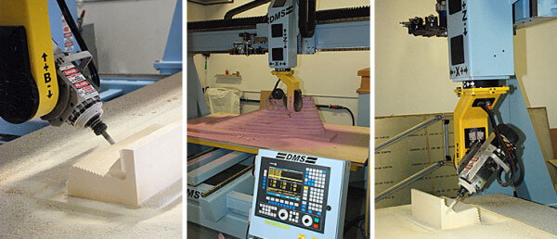
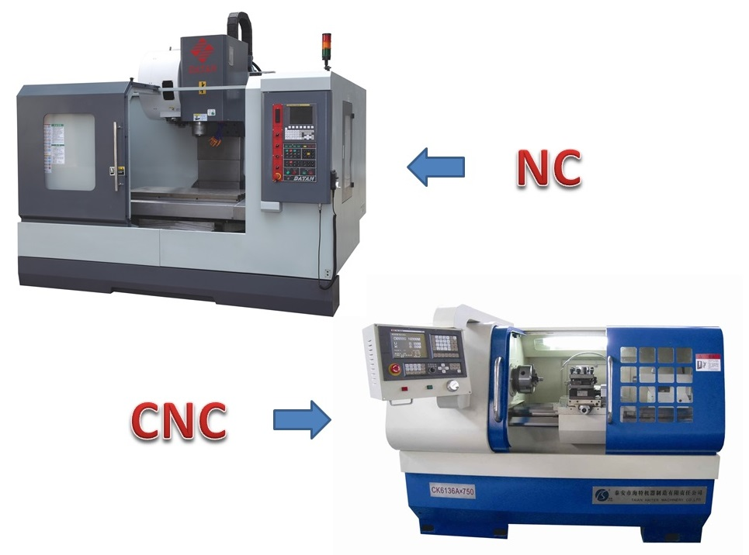
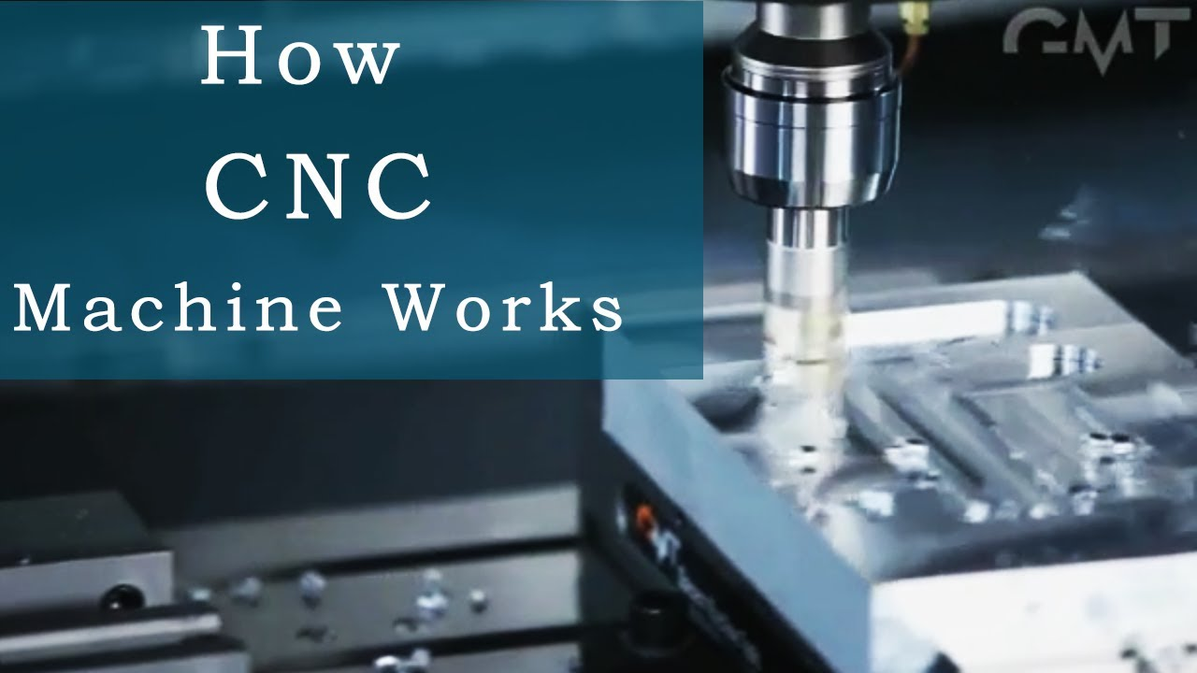

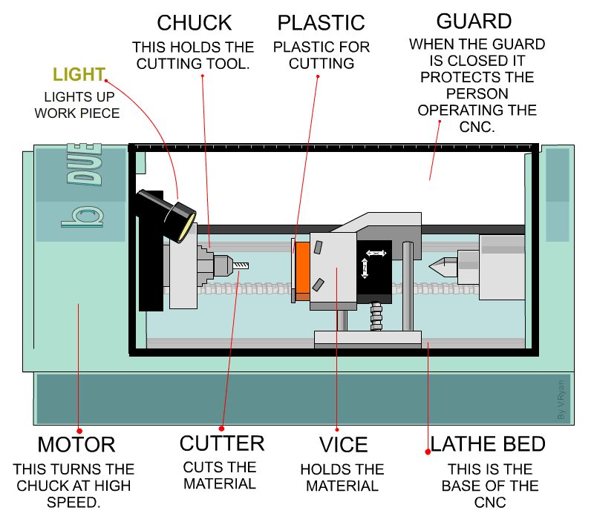

Task 1. UNDERSTANDING THE PASSAGE Answer the following questions
- Where is the program in the CNC machine stored?
------------------------------------------------------------------
------------------------------------------------------------------
- What is the CNC machine?
------------------------------------------------------------------
------------------------------------------------------------------
How does the CNC machine work?
------------------------------------------------------------------
------------------------------------------------------------------
- Tell some of common machine tools that can run on the CNC.
------------------------------------------------------------------
------------------------------------------------------------------
- What is the main purpose of these machines?
------------------------------------------------------------------
------------------------------------------------------------------
Task 2. Are these sentences true or false? Correct the false sentences.
- The CNC machine has the similar parts.
- Compared to the CN machine, the CNC machine offers greater additional flexibility and computional capabliity.

- The CNC machine comprises of the computer in which the program is fed for finding the mental.

- In the CNC machine the role of the operators is maximized.

- All the cutting processes that are to be carried out and all the final dimensions are into the computer via the program.
Task 3. Choose the best answer

- In CNC machines the program of instructions is fed directly into the computer via a ------------ similar to the traditional keyboard.

- small board b. big board c. large board d. very large board

- The programmer can easily write -----------, and edit the programs as per the requirements.

- the code b.the codes c. the metal d. the cotroller

- New systems can be incorporated into the CNC controller simply --------- the unit.

- by programming b.by the operator c.by reprogramming d. of the work

- CNC machine works like the -----------, which has to be fed with the program and it follows all your instructions.
- person b. Robot c. animal d. man

- The CNC machine operators of these days prefer to operate the machine by programming instead of operating it ----------

- Likely b. luckily c. family d. manually

II. VOCABULARY

- Computer Numerical control = CNC Điều khiển máy tính số

- Instruction (n) lời hướng dẫn

- feed (v) cung cấp vật liệu cho

(Feed – fed – fed)

- control (v, n) điều chỉnh, sự kiểm soát

- controller (n) người điều khiển, (kỹ thuật) bộ điều chỉnh (nhiệt độ, áp lực, tốc độ của máy…)

- controller unit = CU bộ điều khiển

- microcomputer(n) small computer, personal computer

- punch card (n) thẻ đục lỗ

- board (n) tấm ván, bảng

- memory (n) (tin học) bộ nhớ của máy tính

- program (n) chương trình ( của máy tính)

- programmer (n) lập trình viên

- code(n) mã, mật mã

- as per: theo như

- require(v) yêu cầu

- requirement(n) nhu cầu

- part (n) bộ phận

- flexibility (n) sự linh động, sự uyển chuyển

- capability.(n) khả năng

- computational (n) có sử dụng máy tính điện toán

- system (n) hệ thống

- incorporate (v)

- reprogramming

- capacity (n)

- flexibility (n)

- soft-wired (a)

- metal (n)

- process(n)

- to be carried out

- dimension (v)

- via

- follow (v)

- main (a)

- purpose (n)

- shape (n)

- round (n)

- rectangular (n)

- operate (v)

- operator (n)

- operation (n)

- expert (v)

- expert (n)

- to be machined

- precision (n)

- machine tool (n)

- compulsory (n)

- pick up (v)

- fabrication work (n)

- monitoring

- initially (adv)

- raw material (n)

